Evan Carnevale

Professor Albluwi

CSC 110

March 14th, 2016

Homework 7

Problem #1 output:

# Macintosh HD:Users:ecarnevale:Desktop:Screen Shot 2016-03-14 at 2.46.15 PM.pngLinear:

# Macintosh HD:Users:ecarnevale:Desktop:Screen Shot 2016-03-14 at 2.47.45 PM.png

# Binary:

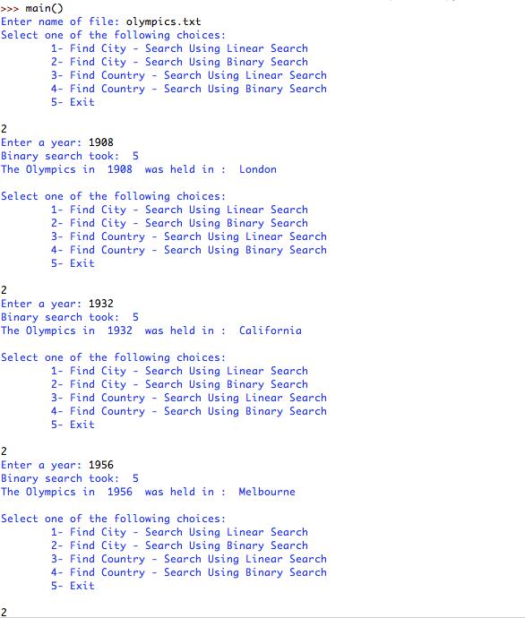(I may have different values for my Binary Search output because I started my counter at 1 as opposed to 0)

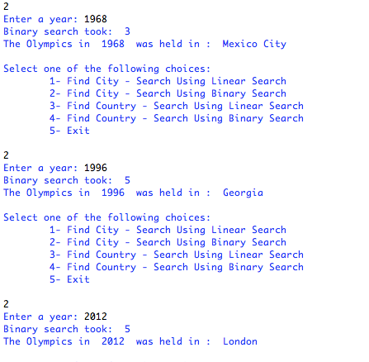

Problem #2 output: (definitely needed more time on this problem & I could have figured this out)

Macintosh HD:Users:ecarnevale:Desktop:Screen Shot 2016-03-14 at 11.29.10 PM.png